**Introduction to Employee Training and Development**

**Objectives**

1. Discuss the forces influencing the workplace and learning and explain how training can help companies deal with these forces.

2. Discuss various aspects of the training design process.

3. Describe the amount and types of training occurring in U.S. companies. Describe

4.how much money is spent on training in U.S. companies and how the money is used.

5. Discuss the key roles for training profession ales.

6. Identify appropriate resources (e.g., journals, Web sites) for learning about training research and practice

**INTRODUCTION**

Competitiveness refers to a company's ability to maintain and gain market share in an industry. Companies are experiencing great change due to new technologies, rapid development of knowledge, globalization of business, and development of e-commerce Also, companies have to take steps to attract, retain, and motivate their work forces. Trainings not a luxury; it is a necessity if companies are to participate in the global and electronic marketplaces by offering high-quality products and services. Training prepares employees to use new technologies, function in new work systems such as virtual teams, and communicate and cooperate with peers or customers who may be from different cultural backgrounds.

**WHAT IS TRAINING?**

Training refers to a planned effort by a company to facilitate employees' learning of job-related competencies These competencies include knowledge, skills, or behaviors that are critical for successful job performance. The goal of training is for employees to master the knowledge, skill, and behaviors emphasized in training programs and to apply them to their day-to-day activities Why? Because Employees will be required not only to understand the service or product development system but also to share knowledge and to creatively use it to modify a product or serve the customer.

**DESIGNING EFFECTIVE TRAINING**

The training design process refers to a systematic approach for developing training programs.

Training Design Process Steps:

1. Conduct a needs assessment, which is necessary to identify whether training is needed.

2. Ensure that employees have the motivation and basic skills necessary to master the training content.

3. Create a learning environment that has the features necessary for learning to occur.

4. Ensure that trainees apply the training content to their jobs.

5. Develop an evaluation plan.

6. Choose the training method based on the learning objectives and learning environment.

7. Evaluate the program and make changes in it or revisit any of the earlier steps in the process to improve the program so that learning, behavior, change, and the other learning objectives are obtained.

**THE FORCES INFLUENCING WORKING AND LEARNING**

Economic cycles Globalization Increased value placed on intangible assets and human capita Focus on link to business strategy Changing demographics and diversity of the work force Talent Management Customer service and quality emphasis New technology

**Challenges with New Technology**

Not all trainees may be comfortable with technology It may be difficult to engage trainees and ensure compliance with training Some trainees may desire greater "live" interaction with trainers. All rights reserved. No reproduction or distribution without the prior written consent of McGraw-Hill Education

**Training design process steps:**

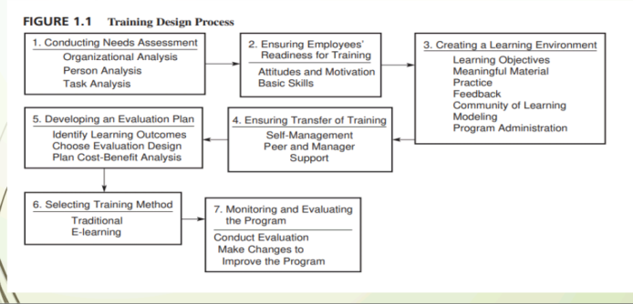

High Performance Systems Work teams Employees interact to assemble a product or provide a service Cross training Training employees in a range of skills to fill roles needed to be performed Virtual teams Teams separated by time, geographic, and organizational boundaries Snapshot of Training Practices Direct expenditures have remained stable Increased demand for specialized learning that includes professional or industry-specific content Use of technology-based learning has increased Self-paced online learning is the most common technology-based learning